Fase de Analisis:

Functional and no functional requirements

No functional requirements
- Compatibility
- Visibility
- Efficient
- Accessibility
- Usability
- Security (?

Technologies
- Server Operative System
  - Ubuntu
- Web Server Software
  - Apache2
- Database Engine
  - MariaDB
- Programming Language
  - PHP
- Client-Side Coding
  - HTML
  - CSS
  - JavaScript
  - Bootstrap
- Browsers
  - Firefox
  - Chrome
  - Edge
  - Safari (?

Functional requirements

Use Case Actor Census
Actor | Responsibility | Requirement | Guide
User | -A person who wants to use the application and wants to have a better life. | -Any user that has email. | -The users can see their calendar  -The users can modify their schedules, to do list, mood tracker, financial tracker...

Use Case Census
- Sign up / Sign In
- Manage Contact list
  - Add, Modify and Delete Contacts
- Manage To Do List
  - Add and Modify To Do List
    - Set / Change Tag name
      - Manage Tasks
      - Check / Uncheck Important tasks
      - Set Contact
    - Set / Change Description
    - Set type of the To do list
      - Normal
      - Challenge
  - Delete To Do List
- Manage Mood Tracker
  - Select daily mood
  - Show Mood Calendar
  - Set daily mood
- Manage Financial Tracker
  - Enable and Disable function
  - Set Total and Income
  - Set Daily Expenses
    - Set Expenses name and quantity
  - Show Money Stats and Graphic
- Manage Scheduler
  - Add / Change daily entries
  - Delete entries
- Show current schedule
- Show current Schedule
- Show current To do list
- Show Calendar
  - Show Schedule
  - Show To Do List
  - Show Exposes and Income
  - Show mood

Analysis Class Diagram

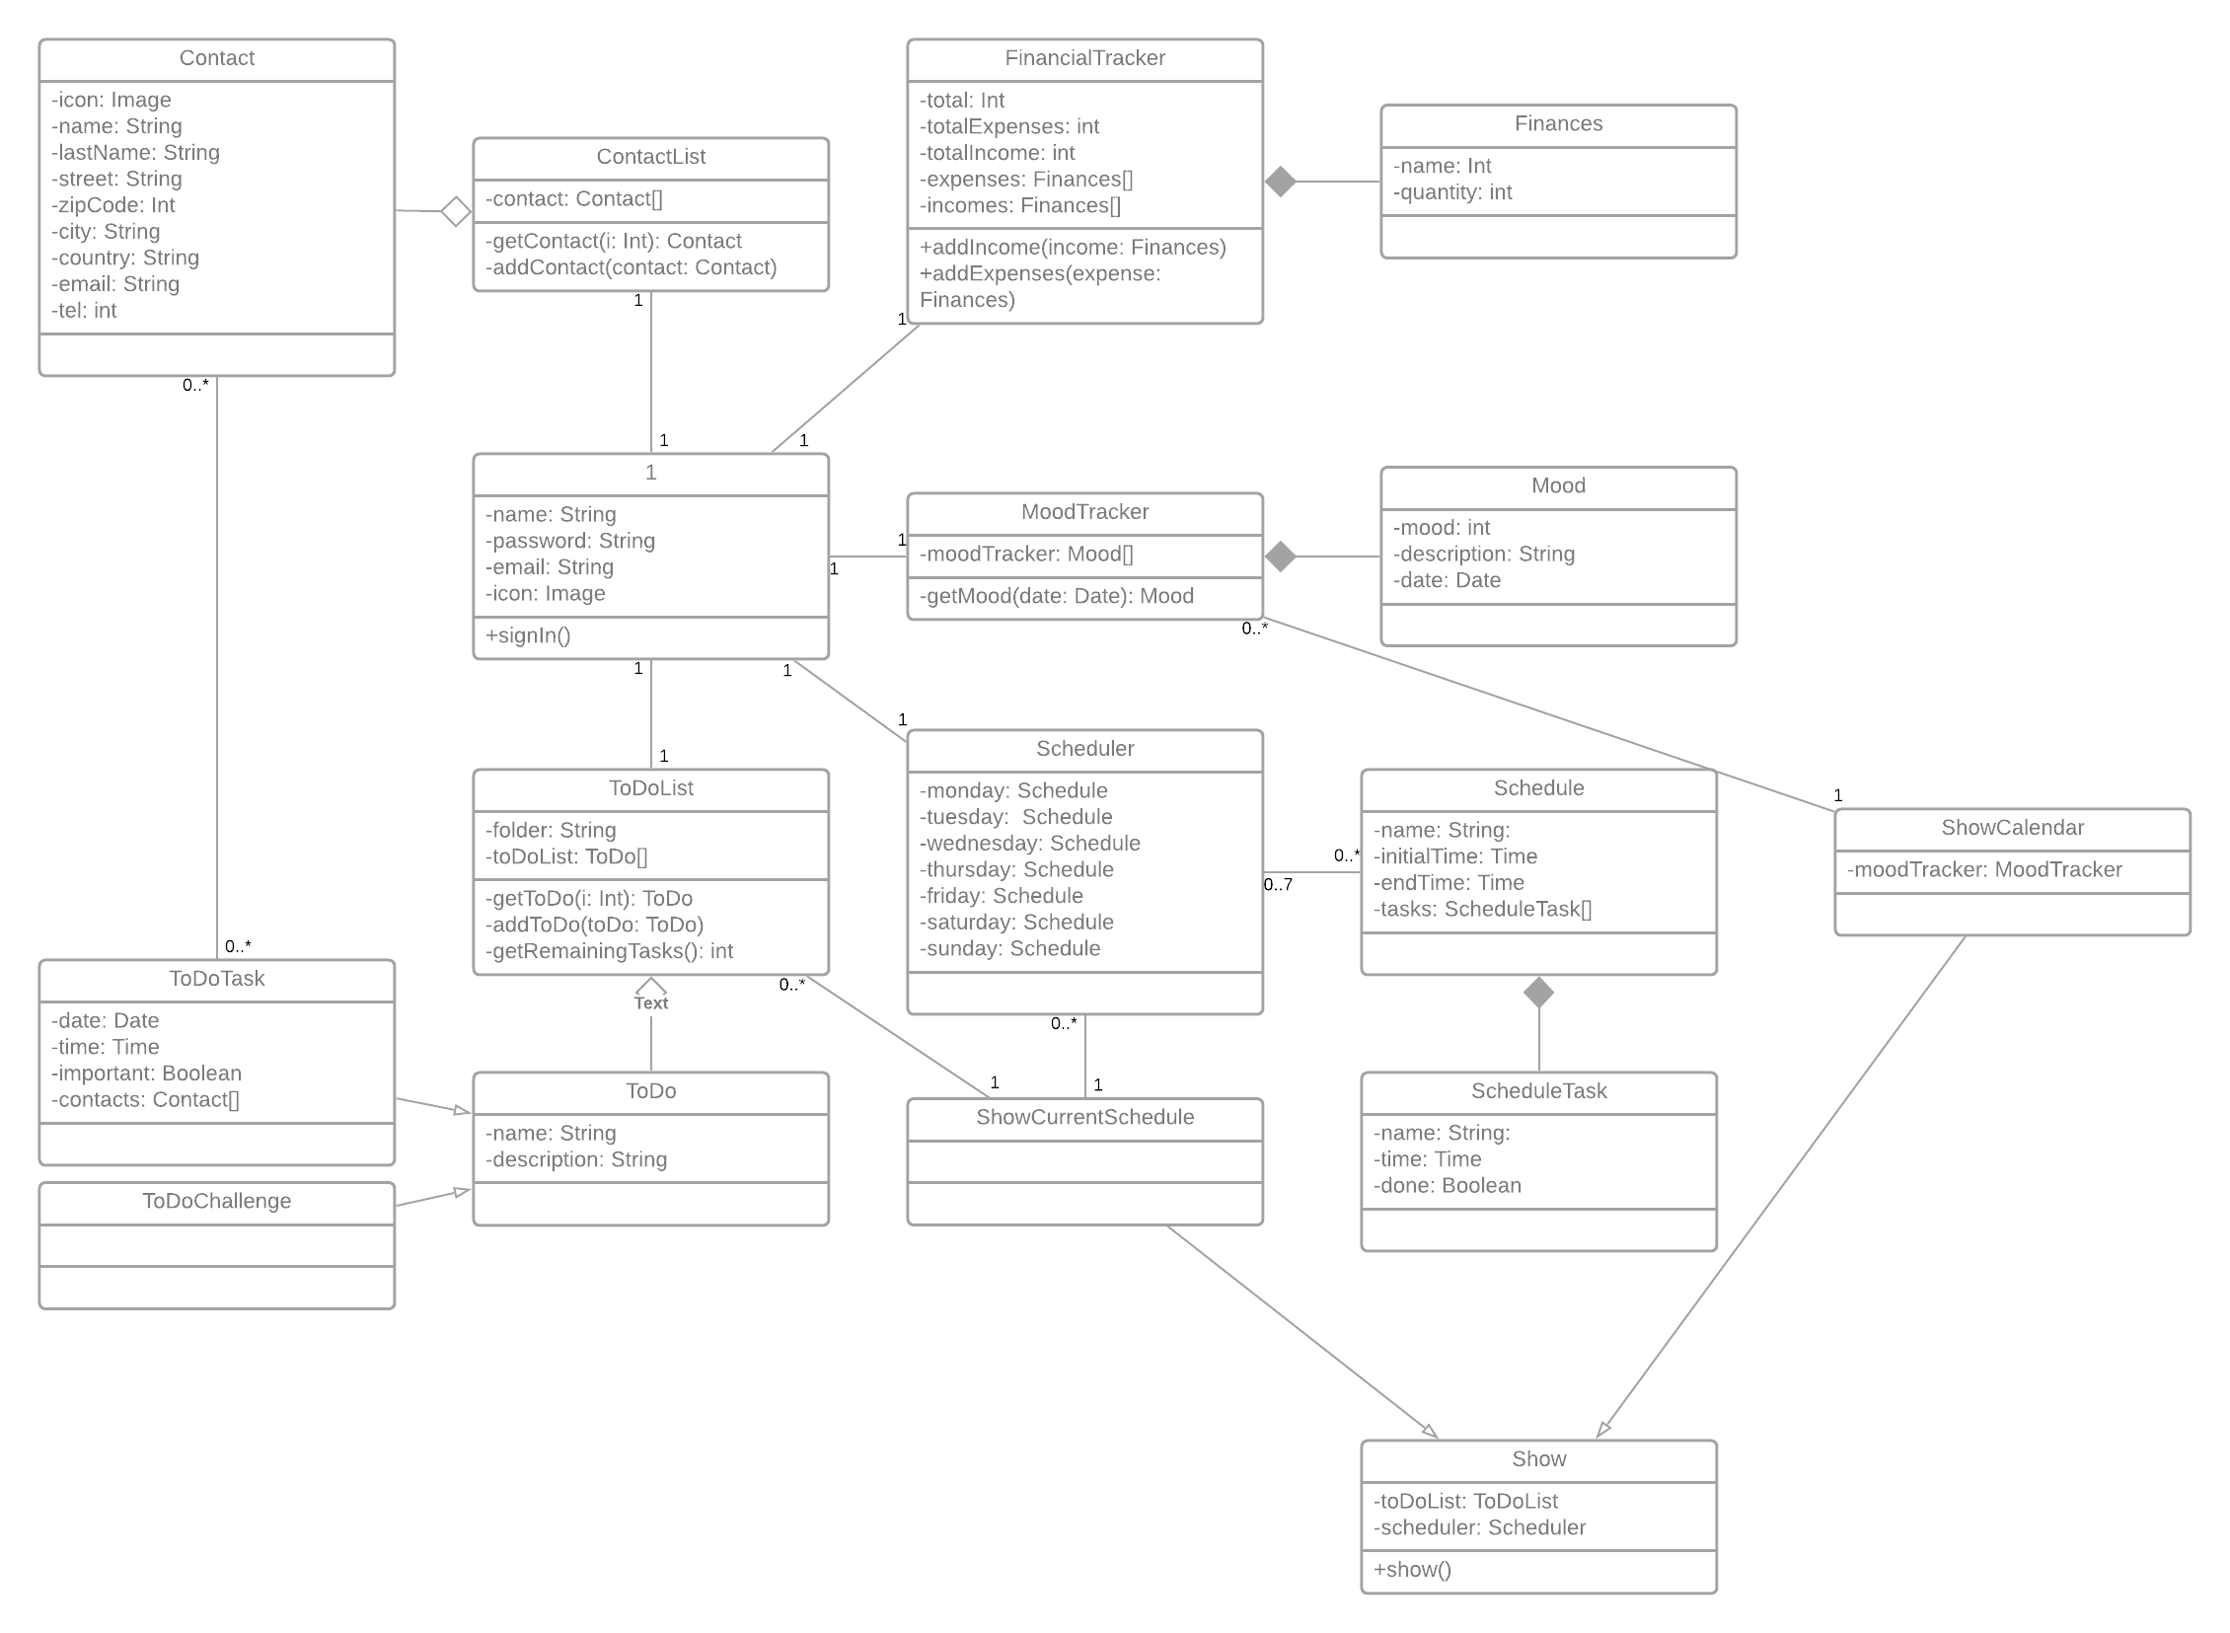
Use Case Diagram
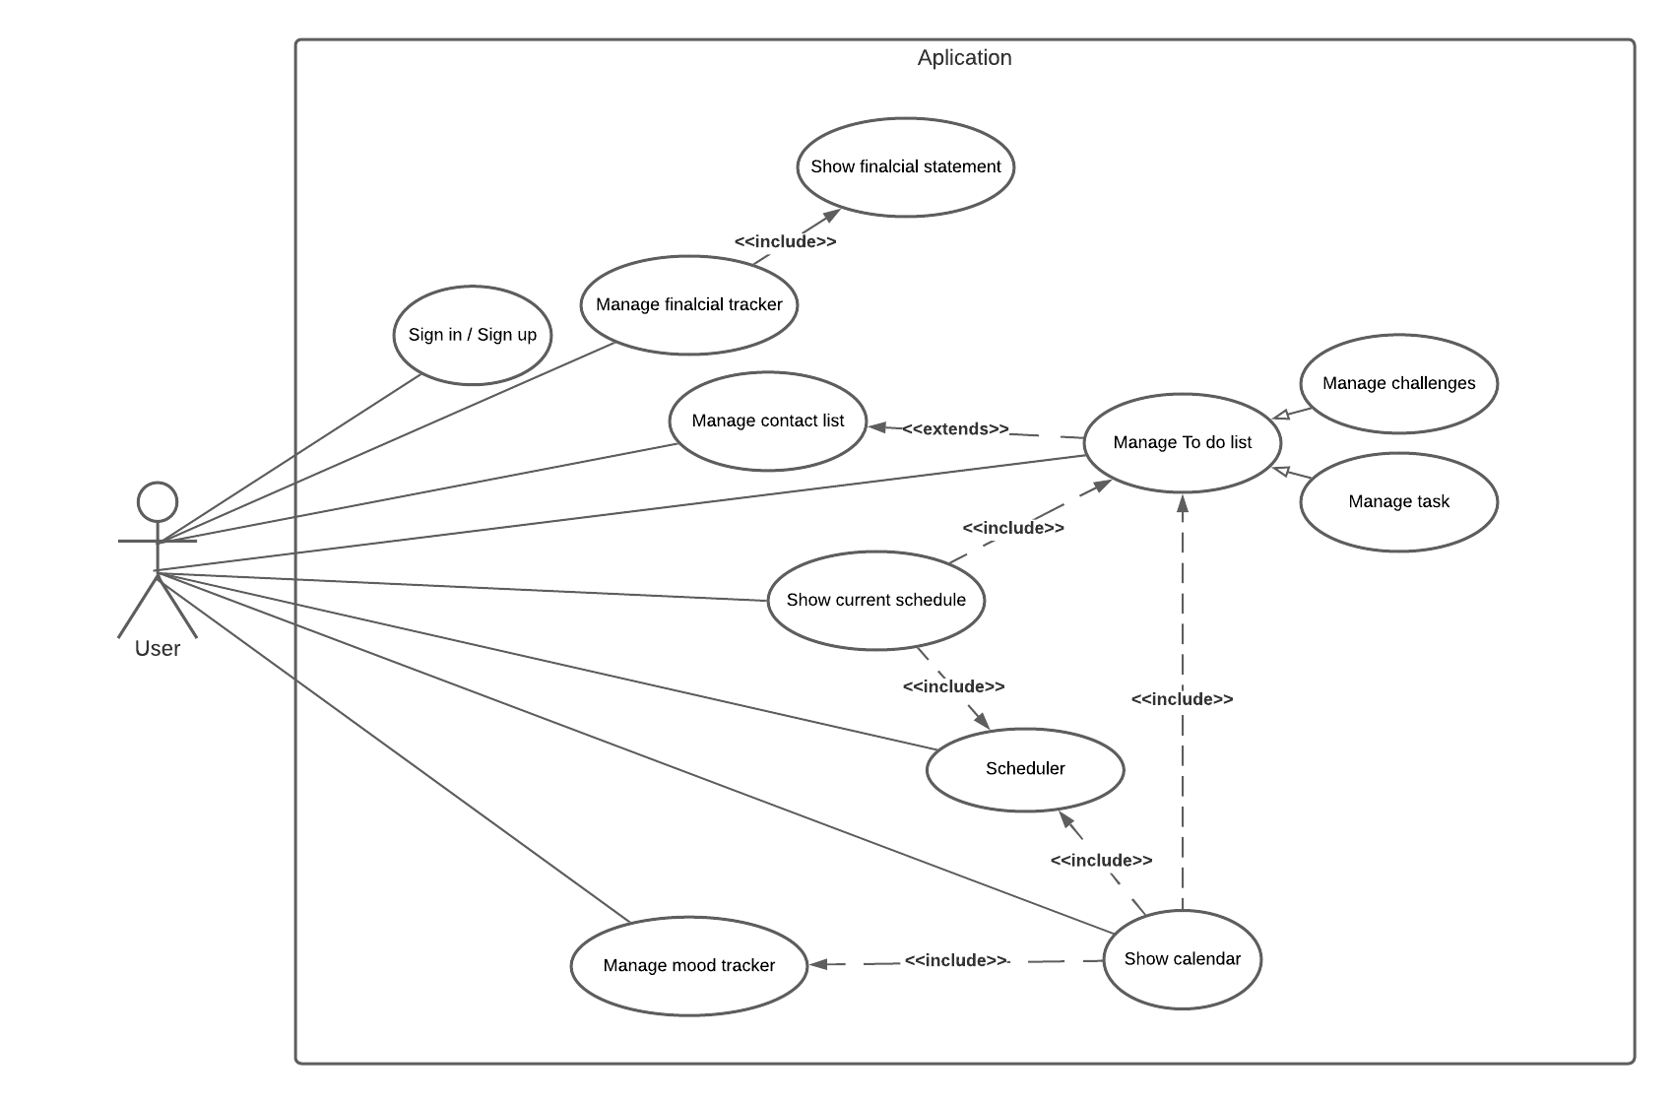

Use Case Specification
Use Case | Sign up
Pre-condition | - The user doesn’t have an account to access to the application.  - The user must have an email to register to the application  - The web side is online properly
Post-condition | - Account created for the user to access to the application
Basic Path | - The user puts its email, password and password verification to create an account.  - The system checks if both password coincide.  - The system saves the data to its database
Alternative paths | 2a The passwords don’t coincide.  2b Email already in use  2c Invalid email format
Exception paths | - Cannot create the account  - Cannot create new account  - The application cannot connect to the database

Use Case | Sign in
Pre-condition | - The user must have an account to access to the application  - The web side is online properly
Post-condition | - The user acceded to the application and its functionalities.
Basic Path | - The user enters his email and password.  - The system verifies his email and password, comparing to the database’s.  - The email and password are correct
Alternative paths | 3a. The email or account doesn’t exist.  3b. The password is incorrect
Exception paths | - Cannot access to the application  - The application cannot connect to the database

Use Case | Manage contact list
Pre-condition | - The user already signed in  - The web side is online properly
Post-condition | - The user added a new contact  - The user modified a contact  - The user deleted the contacts  - The database changed / updated the data  - The user sees the information
Basic Path | - The user go to the Contact List page  - The system gets the information of the users contact  - The user manages the contact list:  - The user want to add a new contact  - The user clicks the button to add a new contact  - The system shows to the user a screen to add a new contact.  - The user enters the new contact’s information (Name, Last name, Phone, Email, etc) and confirms  - The system adds the new contact with the information given by the user to the database  - The user wants to edit a contact  - The user clicks the edit button of the interested contact  - The system shows to the user a screen to edit the selected contact.  - The user changes the information of the contact and confirms  - The system updates the information changed by the user to the database  - The user wants to delete a contact  - The user clicks the delete button of the interested contact  - The system asks if the user wants to delete the contact or not  - The user chooses “yes”  - The system deletes the contact from the database  - The system updates and now shows the contact page without the deleted contact
Alternative paths | 2a. The application shows no information of the users contact, because there’s none  3.1.3a The user denies on adding a new contact  3.2.3a The user denies on modifying the contact  3.3.3a The user chooses “no”  3.3.4b The system doesn’t delete the contact
Exception paths | - The application cannot connect to the database

Use Case | Manage To Do list (folders)
Pre-condition | - The web side is online properly  - The user already signed in
Post-condition | - The user added a new folder  - The user modified a folder  - The user deleted a folder  - The user enters to a folder  - The database changed / updated the data  - The user sees the information
Basic Path | - The user go to the To do list page  - The system loads the “folders” and shows to the user  - The user manages the folders:  - The user enters to a folder  - The user click to the interested folder and enters  - The application shows the tasks within the folder  - The user adds a new folder  - The user click on add new folder  - The system gives to the user a form to set a name  - The user puts a names for the new folder and confirms  - The system creates a new folder and inserts into the database  - The user renames a folder  - The user clicks edit on the interested folder  - The system leads the user to another page  - The system loads the old name of the folder  - The user changes the old name of the folder and confirms  - The system updates the folder’s name and updates into the database  - The user deletes a folder  - The user click delete on the interested folder  - The system asks the user to delete the folder  - The user accepts  - The system deletes the folder from the database and reloads the page
Alternative paths | 2a There’s no folders  3.2.3a The user denies on adding a new folder  3.2.4a The system doesn’t add a new folder  3.3.4a The user denies on modifying the folder  3.3.5a The system doesn’t modify the folder  3.4.3a The user denies on deleting the folder  3.4.4a The system doesn’t delete the folder
Exception paths | - The application cannot connect to the database

Use Case | Manage To Do list (tasks and challenges)
Pre-condition | - The web side is online properly  - The user already signed in  - There must be folders created first  - The user must have selected the folder first
Post-condition | - The user added a new task/challenge  - The user modified a task/challenge  - The user deleted a task/challenge  - The database changed / updated the data  - The user sees the information
Basic Path | - The user chooses the folder  - The system shows to the user the tasks or challenges created  - The user manages the tasks:  - The user adds a new task  - The user clicks on add new task  - The system gives to the user a form about the task  - The users enters all the information (name, important check, date, time and contact).  - The system gets the information and inserts in to the database  - The user modifies a task  - The user clicks on the interested to edit  - The system loads the task information to edit  - The user changes the information about the task and confirms  - The System updates the information to the database  - The user deletes a task  - The user clicks on the interested task to delete  - The system asks the user to delete  - The user confirm it.  - The system delete the task from the database
Alternative paths | 2a There’s no task or challenge  3.1.3a The user changes the type of the task to “challenge” and enters the information (only name)  3.1.4a The system didn’t add a new task  3.2.3a The user changes task to normal or to challenge type, and the system changes the form  3.2.4a The system didn’t update the tasks  3.3.3a The user denies the confirmation  3.3.4a The system didn’t delete the task
Exception paths | - The application cannot connect to the database

Use Case | Manage mood tracker
Pre-condition | - The web side is online properly  - The user already signed in
Post-condition | - The user set his mood of the day  - The user set a description of his day  - The database updated the data
Basic Path | - The user goes to the mood tracker page  - The system shows the page to the user  - The user selects his mood and writes a description of the day  - The user clicks on the confirm button  - The system adds a new entry to the database
Alternative paths | 2a The system loads the mood and the description wrote previously  5a The system updates the entry if it already exists
Exception paths | - The application cannot connect to the database

Use Case | Manage Financial tracker
Pre-condition | - The web side is online properly  - The user already signed in  - The Financial tracker is enabled
Post-condition | - The user sees his information about the expenses, income and total  - The user sees his information about all the different expenses and incomes
Basic Path | - The user goes to the financial page  - The system shows all his financial information  - The user adds/modifies/deletes and expense or income  - The system inserts/updates/deletes the entry from the database
Alternative paths | 5. The user click on the old transaction button  6. The system shows to the user the transactions of the everyday
Exception paths | - The application cannot connect to the database

Use Case | Manage Scheduler
Pre-condition | - The web side is online properly  - The user already signed in
Post-condition | - The user set his schedule  - The database updated the data
Basic Path | - The user goes to the scheduler page  - The system shows the scheduler  - The user chooses which day of the week will he modify  - The system shows the information about that day  - The user adds, modifies or deletes entries and confirms  - The system makes the changes on the database
Alternative paths | 5a The user doesn’t want to make the changes
Exception paths | - The application cannot connect to the database

Use Case | Show Current schedule (Main page)
Pre-condition | - The web side is online properly  - The user already signed in
Post-condition | - The user sees his data  - The user sees his daily Schedule and its information (Schedule and To do)
Basic Path | - The user goes to the main page  - The system loads from the database the information about the schedule and to do list  - The system uses those information to make a list and shows to the user
Alternative paths
Exception paths | - The application cannot connect to the database

Use Case | Show Calendar
Pre-condition | - The web side is online properly  - The user already signed in
Post-condition | - The user sees his data  - The user sees his monthly calendar and its information (To do, mood, financial, etc).
Basic Path | - The user goes to the calendar page  - The system loads from the database the information about the schedule, to do list, financial tracker and mood tracker  - The system put those information in a calendar and shows to the user  - The user click on a certain date  - The system shows to the user a summary of that day
Alternative paths
Exception paths | - The application cannot connect to the database

Bibliography
Visual Paradigm: “ What is Use Case Specification? ”, URL: https://www.visual-paradigm.com/guide/use-case/what-is-use-case-specification/
“Simple Gantt Template”: r/x365 , URL: https://www.reddit.com/r/excel/comments/axedht/simple_gantt_template/
Stack Exchange Inc: Stack Overflow, URL: https://stackoverflow.com/
Vagrant: HashiCorp, URL: https://www.vagrantup.com/
Apache NetBeans: The Apache Software Foundation, URL: https://netbeans.apache.org/
W3Schools: Refsnes Data, URL: https://www.w3schools.com/
Fonticons, Inc.: Font Awesome, URL: https://fontawesome.com/
MIT: Bootstrap, URL: https://getbootstrap.com/
PHP: The PHP Group, URL: https://www.php.net/
MariaDB Server: MariaDB Foundation, URL: https://mariadb.org/
Apache: The Apache Software Foundation, URL: https://httpd.apache.org/
Git: Software Freedom Conservancy, URL: https://git-scm.com/
CodePen: CodePen, URL: https://codepen.io/
Lucid Chart: Lucid, URL: https://lucid.app/
"Event Calendar Widget (non demo)”: Paul Navasard,URL: https://codepen.io/peanav/pen/CfFjl

